Stop Bank of America’s foreclosure on the Musni Family
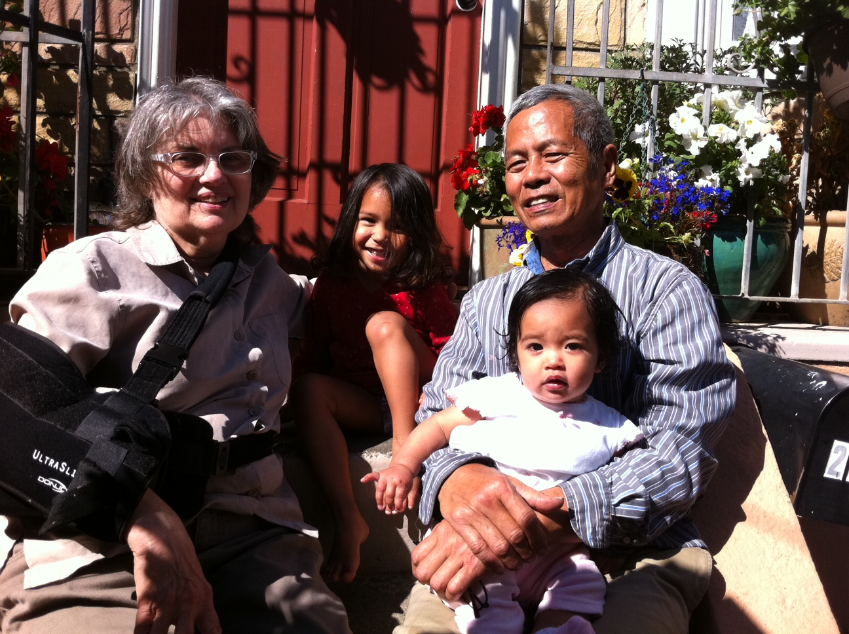
Next Wednesday, July 25th, BofA plans to auction off the Musni family home of 40 years, even though the bank continues to accept their checks ($17,000 in last 3 months). This is called “dual tracking”, an unethical practice that as of January 2013 will be illegal. But for now, the Musnis, their children and their grandchildren are at risk of losing their home next week.
Merrie Jo, a labor & delivery nurse who’s assisted in more than 5,000 deliveries, has had medical injuries and surgeries which have led to a decrease in income. The Musnis need a reasonable modification, and have complied with steps the bank has demanded, depleting their savings, all the while getting the run around from the bank for 4 years, each time talking with a different person and starting all over. We must stop this auction. MerrieJo Musni says, “What we have paid in the trial period is impossible to continue and is basically a slower death.” Meanwhile, BofA CEO Moynihan made $10,000,000 in 2010 alone.
Occupy Noe is working with neighbors and homeowners to stop foreclosures. In zip codes 94114 & 94131 alone, there are nearly 70 foreclosures. Help stop these foreclosures and ensure families can stay in their homes.

What Can You Do?
* Sign the petition to stop the foreclosure next week on the Musnis.
* Call CEO Brian Moynihan at BofA, at 704-386-5681 (then press 2) to demand they stop the July 25th auction, negotiate a reasonable modification, and halt all foreclosures immediately. Tell him it’s Loan #149979475/Musni/S.F.
* Join Occupy Noe. For more info, call 415-641-1997 or 641-6012.

